Enhancing Wazuh SIEM with cross layer Security and Artificial Intelligence Based Anomaly Detection




Submitted By
Hamad Ali F22605010  Muhammad Awais F22605035  Amir Ali F22605044  Muhammad Zohaib Arif F22605046 | Supervised By  Lec. Babar Yousaf  Co- Supervised By  Lec. Saima Yasmeen

Department of Computer Science National University of Technology (NUTECH)
Islamabad, Pakistan 2026

Enhancing Wazuh SIEM with cross layer Security and Artificial Intelligence Based Anomaly Detection




By
Muhammad Awais | F22605035
Hamad Ali | F22605010
Amir Ali | F22605044
Muhammad Zohaib Arif | F22605046

A Project Report Submitted to the Department of Computer Science in partial fulfillment of the requirements for the degree of Bachelor of Science in Computer Science

Department of Computer Science National University of Technology (NUTECH)
Islamabad, Pakistan 2026

3

BS CS HAMAD, AWAIS, AMIR, ZOHAIB 2026

CERTIFICATE OF APPROVAL
It is certified that the project titled "Enhancing Wazuh SIEM with Cross-Layer Security and AI-Based Anomaly Detection" carried out by Hamad Ali (F22605010), Muhammad Awais (F22605035), Amir Ali (F22605044) and Muhammad Zohaib Arif (F22605046), under the supervision of Lec. Babar Yousaf and co-supervision of Lec. Saima Yasmeen, at National University of Technology (NUTECH), Islamabad, is fully adequate in scope and quality as a capstone project for the degree of BS in Computer Science.
This project addresses modern cybersecurity challenges by integrating cross-layer security monitoring across host systems, network infrastructure, and cloud environments. The increasing complexity of cyber threats creates gaps in traditional monitoring systems, which can be minimized through a centralized and intelligent security platform.
This project aims to solve these challenges by introducing an enhanced SIEM-based solution that utilizes Wazuh along with AI-based anomaly detection techniques. The system provides unified monitoring, efficient log analysis, and proactive threat detection, enabling organizations to strengthen their security posture and respond effectively to potential threats.

Supervisor: -------------------------
Lec. Babar Yousaf Dept. of Computer Science
National University of Technology (NUTECH), Islamabad

HOD: ----------------------------
Professor Dr. Muhammad Rashid Dept. of Computer Science
National University of Technology (NUTECH), Islamabad

ACKNOWLEDGMENT
All thanks and Praise will be to Almighty ALLAH, the Lord of the Universe, who have blessed the mankind with knowledge and wisdom enough to catch its mysteries as well.
We especially thank our supervisors Lec. Babar Yousaf and Lec. Saima Yasmeen who mentored us and guided us at every step of this project. Their guidance has greatly influenced our studies and helped us improve our methodology by providing us constructive criticism.
Moreover, we are thankful and grateful to Lecturer Naveed Yousaf, FYDP Capstone Project Coordinator for his guidance and support to assist us in our project. They have accompanied us throughout our studies until now and also given us constructive criticism to improve our methodology. His contributions have been invaluable in moving research along and ensuring that projects run smoothly during the execution stage.
Our project, focused on enhancing Wazuh SIEM with cross-layer security and AI-based anomaly detection, is a continuous effort and will keep evolving to meet modern cybersecurity demands efficiently and intelligently. We are thankful for the continued support and engagement of our mentors and collaborators, who helped make this platform a strong solution for addressing complex security challenges in today’s digital environments.

ABSTRACT

With more and more interconnected systems in host, network and cloud-based architectures, this has become a significant concern for cyber security in today's business environments. Lacking intelligent threat detection, multi-layered view and real time correlation across host, network and cloud environments is a known security monitoring shortfall for traditional security monitoring solutions. It's creating an issue for security teams trying to define advanced threats and what to do if something went wrong and they had to cope with the time it would take to sift through a large amount of logs. The security monitoring of all layers and anomaly detection using Artificial Intelligence (AI) is a combined solution addressing these challenges by upgrading the Wazuh Security Information and Event Management (SIEM) system. This platform collects and aggregates all security information from all hosts, network and cloud infrastructure into a smooth and systematic monitoring. This system provides increased visibility and security operations, plus built-in log collection, intrusion detection and intelligent analysis, to provide added security value. The recommended solution will include the implementation of a centralized logging and cloud monitoring system, such as a log collector, in addition to Wazuh integration with the network based intrusion detection systems (NIDS) such as Suricata and some central monitoring and log collection areas. The system adopted adopts AI to detect anomalies, analyse behaviours and classify intelligently in host, network and cloud environment, to boost the detection accuracy and reduce false-positives. Allows for centralized monitoring, intelligent alerting, and real-time, dashboard visualization to facilitate efficient threat detection, and timely incident response at host, network and cloud layers. All the platform is developed using modern technologies such as a Wazuh SIEM for Logs collection and visualization, and Python-based machine learning models for anomaly detection. The system is scalable, efficient and fits in real world organizational environments. The AI-driven multi-layer security monitoring system provides substantial boosts in threat detection accuracy and lowers the amount of manual analysis needed to increase a modern IT infrastructure's overall security. Wazuh's combination of host, network, and cloud layers, along with the AI-driven anomaly detection, facilitates centralized monitoring, instant threat analysis, and quick response time with efficient visualization and security analytics.

TABLE OF CONTENTS

CERTIFICATE OF APPROVAL 4
ACKNOWLEDGMENT 5
ABSTRACT 6
LIST OF FIGURES 11
LIST OF TABLES 12
LIST OF ABBREVIATIONS & ACRONYMNS 13
Chapter 1: Introduction 14
  - Background 14
  - Problem Statement 15
  - Objectives 16
  - Scope 17
  - Project Outline 18
Chapter 2: Literature Review 20
  - Host-Based Security Monitoring 20
  - Network-Based Security Monitoring 20
  - Cloud Security Monitoring 21
  - SIEM Systems and Event Correlation 22
  - AI-Based Anomaly Detection 22
  - Research Gap……………………..……………………..…………………………….... 23
  - Conclusion…………..……………………..…………………………………………… 24
Chapter 3: System Design 26
  - Overview 26
    - The Need for advanced SIEM Systems 26
    - AI Based Anomaly Detection System 26
    - Automated Security Log Analysis 26

Enhancing User Experience with Rel-Time Insights 27
    - Future Enhancements and Expansions 27
Languages, Frameworks, and Tools 28
Architecture 29
3.3.1 Wazuh SIEM Architecture 30
    - Host Based Monitoring 31
    - Network Monitoring 33
    - Cloud Monitoring 33
    - Backend Processing and Log management 34
    - Database (Elasticsearch/Log storage) 34
    - Dashboard Visualization (Kibana) 35
Workflow 35
    - Log Collection Process 35
    - Log Processing and Normalization 37
    - Alert Generation and Correlation 39
    - Anamoly Detection Workflow 40
    - Notifications & Alerts 40
Chapter 4: System Requirements and Specifications………………………………………...42
4.1 Overview……………………………………………………………………………… 42
4.2 Functional Requirements………………………………………………………………... 42
4.2.1 Real-Time Monitoring……………………………………………………. 42
4.2.2 Centralized Log Collection……………………………………………… 42
4.2.3 Threat Detection………………………………………………………… 43
4.2.4 AI-Based Anomaly Detection…………………………………………… 43
4.2.5 Alert Generation and Notification…………………………………………. 44
4.2.6 Dashboard Visualization………………………………………………… 44
4.3 Non-Functional Requirements……………………………………………………… 44
4.3.1 Performance……………………………………………………………… 44
4.3.2 Scalability………………………………………………………………… 45
4.3.3 Reliability………………………………………………………………… 45
4.3.4 Security……………………………………………………………………. 45
4.3.5 Usability…………………………………………………………………… 46
4.3.6 Maintainability…………………………………………………………….. 46
4.4 Hardware Requirements………………………………………………………………… 47
4.5 Software Requirements…………………………………………………………………. 47
4.6 System Constraints……………………………………………………………………… 48
4.7 Summary……………………………………………………………………………….. 48
Chapter 5: Implementation 49
  - Functional Features 49
    - Real Time Monitoring Feature 49
    - Threat Detection and Alerting Feature 52
  - System Setup and Configuration 53
    - Wazuh server installation 53
    - Wazuh agent configuration 54
    - Host network and cloud integration 55
    - IDS and Firewall integration 57
    - Log collection and processing 58
    - Log Aggregation using Wazuh 60
  - Machine Learning and anomaly detection 62
    - Machine Learning model 60
    - Isolation Forest Classification Model 64
    - Anomaly Detection Process 66
  - Integration and System Workflow 68
    - Dashboard Flow and Monitoring Interface 68
    - Log Storage and Processing Pipeline 69
  - Integration and System Workflow 71
  - Future Enhancements 73
Chapter 6: Result Evaluation 75
6.1 Experimental Setup 75
Attack Scenerios 76
Performance Evaluation 77
6.3.1 Network Layer Model Evaluation 77
6.3.2 Cloud Layer Model Evaluation 78
6.3.3 Host Layer Model Evaluation 78
Chapter 7: Project Follow-Up and Difficulties faced 79
  - Progress 79
  - Difficulties faced 80
Chapter 8: Conclusion and Future Enhancement 82
REFERENCES 84

LIST OF FIGURES
Figure 1: Project Chapters Outline 18
Figure 2: Architecture diagram of project 22
Figure 3: Wazuh Dashboard Visualization 24
Figure 4: Host connected with wazuh 25
Figure 5:Host logs on Wazuh Dahboard 26
Figure 6: Host Logs on Threat Hunting 26
Figure 7: Connected Machines Using Wazuh-agent 29
Figure 8: Workflow 31
Figure 9: Alerts visualization on Wazuh 33
Figure 10: Command for installation of wazuh agent 39

LIST OF TABLES
Table 1 : Components and Technologies 21
Table 2: Tech stack for log processing and normalization 31
Table 3: Real time monitoring components 35
Table 4: Real time monitoring Requirements 36
Table 5: Project Progress 56

LIST OF ABBREVIATIONS & ACRONYMNS

Abbreviation | Full Form
SIEM | Security Information and Event Management
IDS | Intrusion Detection System
HIDS | Host-Based Intrusion Detection System
NIDS | Network-Based Intrusion Detection System
AI | Artificial Intelligence
ML | Machine Learning
ELK | Elasticsearch, Logstash, Kibana
JSON | JavaScript Object Notation
API | Application Programming Interface
CLI | Command Line Interface
OS | Operating System
VM | Virtual Machine
UFW | Uncomplicated Firewall
TCP | Transmission Control Protocol
UDP | User Datagram Protocol
IP | Internet Protocol
HTTP | Hypertext Transfer Protocol
HTTPS | Hypertext Transfer Protocol Secure
SSH | Secure Shell
DNS | Domain Name System
CPU | Central Processing Unit
RAM | Random Access Memory
GUI | Graphical User Interface
CSV | Comma-Separated Values
URL | Uniform Resource Locator

Chapter 1: Introduction

Background
With the information age of computerization we live in, the security of an organization's systems, networks, cloud-based infrastructures and data, are increasingly of foremost concern to prevent any wreaking of the environment from cyber threats or unauthorized access. Everyday cyber threats like malware, ransomware, phishing, internal threats, and distributed denial-of-service (DDoS) have become more sophisticated and widespread, posing significant security risks for organizations [12][18]. Organizations start implementing various security technologies such as firewalls, endpoint monitoring tools, intrusion detection systems (IDS), antivirus solutions and log management solutions to keep their digital infrastructures secure [6]. These systems continuously generate huge amount of security logs and events which need to be monitored and analysed for spotting malicious activities and possible security attacks. But manual analysis of security data on a large scale can be cumbersome, inefficient and hard to manage in today's enterprise environments. The goal of introducing the Security Information and Event Management (SIEM) systems was to achieve centralized monitoring, log gathering, correlation of events and analysis of threats [2][9]. Security logs are centrally gathered from multiple sources like host systems, network devices, applications and cloud platforms for monitoring and analysis on SIEM platforms. These systems provide enhanced visibility of security, aid incident response, and provide real-time generation of alerts based on continuous monitoring and event correlation [5]. While these are some benefits, traditional security monitoring systems still suffer from a number of drawbacks. Most organizations currently have distinct monitoring solutions for hosts, networks, firewalls, and cloud infrastructure; with siloed infrastructures that lack cross-layer visibility to other infrastructures [10][13]. This lack of integration makes it difficult correlating security events throughout multiple levels and identifying advanced cyberthreats in realtime. Moreover, conventional rule-based detection techniques do not provide sufficiently accurate detection when unknown, or new threats, arise, not only will unknown attacks go undetected, but so will false alarms, which will result in delayed detection and higher false alarm rates [23]. As recently as last month, researchers from the University of Texas (UT) and the University of Arizona (UA) have made exciting progress on strengthening anomaly detection for cybersecurity monitoring using Artificial Intelligence (AI) and Machine Learning (ML). Conventional system can read huge volume of security logs and analyze an abnormal behavior pattern and detect suspicious activities; however this does not happen as efficiently as in an AI-based security system [1]. Anomaly Detectors, such as Isolation Forest [3] and Deep Learning based models [4] and smart threat classification [25] are common applications of machine learning algorithms. These methods yield more accurate detection, fewer false alarms and facilitate proactive threat identification and response. Current cybersecurity research is also directed towards multi-layer security monitoring that’s centralised, all host systems, network traffic, firewall logs and cloud environments are combined into a single platform [7][11]. For effective security operations, open-source systems like Wazuh offer centralized log management, intrusion detection and event correlation, file integrity monitoring and real-time dashboard visualization capabilities [15]. This research proposes a multi-layer security monitoring system which utilizes the Wazuh SIEM for centralized monitoring in both host and network environments, and also on the cloud. A single, centralized system collects logs from various infrastructure levels and the Wazuh Manager provides rules management services, enabling anomaly detection analysis to be performed on raw logs for the purpose of detecting suspicious behavior and identifying threats using AI. The results of the analysis are then sent to Wazuh to server the alerts, index them and visualize them in the Wazuh dashboard, allowing for better threat detection, cross-layer visibility and swift incident response.

Problem Statement
If you have different and traditional security monitoring systems, then:
- A lack of a Unified Security Platform: There are several tools which are used on a per-organization basis, such as: host based monitoring, network intrusion detection systems and logs in the firewalls. This isolation makes it difficult to connect or relate events to one another and be able to have a full vision of a security posture.
- No efficient Log Analysis: A lot of log data are generated in diverse systems, which is difficult to analyze manually and inefficient. This has a negative effect on quick threats detection and response.
- Limited Cross-Layer Visibility: In traditional systems, there will be a lack of visibility across both host, network and cloud environments at the same time. Complex attack patterns over multiple layers, then, often go undetected.
- Lack of Intelligent Threat Detection: Traditional systems that rely on rule-based detection have failed to become capable of detecting or identifying new or emerging threats. Only complex cyberattacks are detected without the help of AI technology designed to detect anomalies.
- Insufficient Real-Time Alerting and Automation: If there is no support for real-time alerting and automation, the security teams might not be able to respond swiftly enough to threats, which can result in potential damage to the system and compromise.
The goal of this project is to address these security challenges with the development of a more sophisticated solution enabling the observation of traffic at various levels and also the addition of anomaly detection at that level through AI. The system's ability to offer a centralized platform for live log analysis, advanced threat identification and automatic response enhances general security effectivity and decision-making capabilities.

Objectives
The key aim of this project are:
- To have one platform, for central alarm and sharing of SIEM solutions: host-based, network-based and cloud-based in one system to get the picture and be able to analyze security alerts easily.
- To provide centralized logging, for easier log collection, aggregation and analysis across various sources in real time, for improved visibility and efficient operations.
- To provide an integrated cross-layer monitoring system, that’s responsible for amalgamating events from the Wazuh agents, Suricata IDS, the firewall logs and the cloud environments for complete threat detection.
- To implement the Isolation Forest (IF), Random Forest (RF) anomaly detection algorithms, to have more accurate anomaly detection in order to detect potential cyber threat; detect the anomalous patterns.
- To estimate and design scalable and secure deployment of systems, on virtualized and cloud based infrastructure for accessibility, flexibility and system reliability
- To provide real-time alerting and automatic response capabilities, giving security analysts a leg up in quicker incident detection and decreased response timeliness and better decision making capabilities.

Scope
The scope of this project includes the following:
- This thesis paper suggests the design of an AI-based SIEM system for increasing cybersecurity monitoring efficiency by combining host-based, network-based, and cloud-based security data on a single platform.
- The proposed system is designed to assist in collecting, monitoring in real time, and analyzing security logs, which allows one to increase security visibility and respond to potential threats faster.The platform will incorporate cross-layer security monitoring techniques to gather data from multiple sources such as Wazuh agents, Suricata IDS, firewall logs, and cloud environments, ensuring comprehensive coverage of system activities.
- The project involves using cross-layer security monitoring approaches in order to collect data from various resources, such as Wazuh agents, Suricata intrusion detection systems, firewalls, and cloud platforms in order to ensure the completeness of system monitoring.
- Anomaly detection models based on machine learning approaches will be used to analyze security logs and provide useful insights about suspicious activity without requiring any specific rules.
- The project will be implemented and tested in both virtual and cloud-based environments to validate the project's performance and effectiveness in real world.
- Log management and processing are key components of the research paper as they help in researching and responding to incidents, when security data is properly managed and processed.

Project Outline
Project outline is divided into 8 chapters as outlined in Figure 1:
• Chapter 1: Introduction – Background, problem statement, Objectives, Scope, and overall structure of the project.
• Chapter 2: Literature Review– Discusses current research related to security monitoring, SIEM systems and AI for anomaly detection.
• Chapter 3: System Design – It includes the following: Description of proposed system architecture, description of system components, system workflows, system monitoring.
• Chapter 4: System Requirements and Specifications – Gives functional and non-functional requirements, system hardware and software requirements, system constraints.
• Chapter 5: Implementation – Describes: implementation process, configuration and integration of the system, machine learning based anomaly detection.
• Chapter 6: Results and Evaluation – Discusses the experimentation setup, attack cases and performance evaluation of the proposed system.
• Chapter 7: Challenges and Limitations – Discusses Discusses the developments and difficulties faced in the project's implementation.
• Chapter 8: Conclusion and Future Work –The conclusion and future enhancement chapter synthesizes project findings and suggests ways to enhance the project.
Conclusion and Future Enhancements
Project Follow-Up and Difficulties Faced
Results Evaluation
Implementation
System Requirements and Specifications
Literature Review
Introduction
System Design
Figure 1: Project Chapters Outline

Chapter 2: Literature Review
2.1 Host-Based Security Monitoring
Host-based monitoring emphasizes identification of suspicious activity within the endpoint systems, like Linux and Windows systems. The host-based intrusion detection systems (HIDS) monitor system logs, user activity, authentication attempts, file integrity change, or processes, to detect abnormal activity.
Khraisat et al. [12] have discussed the various types of intrusion detection techniques and explained significance of host based intrusion detection for detecting any access violation, privilege escalation, and any type of modification using the malicious codes. In their research, they identified host-based systems as offering a comprehensive view of activity on endpoints with the added benefit of reduced latency but with drawbacks of relatively limited scalability and a high level of false positive detections.
Kim and Lee [24] did propose an Intrusion Detection System (IDS) for IoT environment using machine learning. Their research showed how successfully AI-driven methods are making use of system logs and user activity to recognize variations from regular behavior to spot anomalies and errors in endpoint devices.
Wilson and Taylor [15] explained how Wazuh SIEM enhances host monitoring processes by having centralized log collection, real-time monitoring of events and intelligent visualization of alerts. This was reflected in their work on the critical role of centralized monitoring of hosts in Security Operations Centers (SOC).
Host based monitoring is a better way of understanding what is happening on a device—but most approaches we see today are limited to monitoring activity on the device itself, and not integration with network and cloud devices.
2.2 Network-Based Security Monitoring
Network Based Monitoring – A method to analyze network traffic to detect suspicious communication patterns, attacks and malicious activities. Notable tools for real-time network traffic monitoring are Intrusion Detection Systems (IDS) like Suricata and Snort.
Ahmed, Mahmood and Hu discussed various networks anomaly detection methods in recent past review and its limitations of the conventional signature-based detection method [6]. Their analysis revealed that machine learning enhances unfamiliar attack recognition, increased traffic anomaly detection.
Patel and Verma [18] discussed the significance of DDoS detection and mitigation methods in the modern cybersecurity infrastructure. They pointed out that real-time monitoring of traffic could be of very great aid in identifying malicious traffic patterns and distributed attacks.
In Software Defined Networking (SDN) environment, Sharma and Gupta [19] have presented a DDoS attack detection framework. A component of their study was the importance of implementing intelligent traffic analysis and anomaly detection in network infrastructure protection.
The same authors, Khraisat et al. [12] also said that external attacks by the network-based intrusion detection systems can be detected, but normally will not be able to see the activities and internal behavior of hosts.
Existing network monitoring systems are mainly concerned with traffic inspection and intrusion detection, but are unable to monitor everything simultaneously with a central console and host and cloud layers.
2.3 Cloud Security Monitoring
Cloud environments present a number of new threats related to cybersecurity, as they include remote access services, virtual machines, shared resources and a distributed infrastructure. Centralized cloud visibility across systems can be challenging with traditional monitoring methods.
Wang and Chen [21] discussed about cloud security automation techniques to detect threats and deal with incidents. Their research highlighted the importance of automated monitoring and intelligent threat analysis in cloud environments.
Achievements of federated learning in cloud and edge security systems have been discussed by Brown and Garcia [22]. Their findings showed improved security monitoring in the cloud yet remained scalable and private through the use of distributed AI models.
Current cloud monitoring solutions are primarily oriented towards virtual machine activities, cloud authentication logs, and user-access management. Many solutions, however, work autonomously and don't work with cloud security events and host and network monitoring systems.
Since there is no centralized cloud-layer monitoring, there is limited visibility of multi-layered cyberattacks.
2.4 SIEM Systems and Event Correlation
Security Information and Event Management (SIEM) systems gather, process, analyze and correlate security logs from various sources in one central location.
Ahmed and Khan [2] talked about using SIEM with ZTA to enhance the centralized threat detection and security granularity. They found that SIEM systems enable organizations to monitor multiple environments under a single “roof” of software.
Alarm correlation techniques have been proposed by Jakobson and Weissman [5] in the SIEM systems to reconcile introducing related security events and discovering attacks patterns. Event correlation decreases false positive and increases the efficiency of threats investigation.
Kumar and Sharma [7] proposed a SIEM-based framework for multi-layer data collection and hybrid threat detection. Their research emphasized the importance of centralized monitoring for improving incident response and security analytics.
Rehman and Ali [10] provided a description of the way anomaly detection techniques might be used to make open source SIEM platforms more intelligent in threat analysis and real-time monitoring.
While SIEM systems can enhance centralized log management, many traditional SIEM solutions still mainly depend on rule-based detection, instead of incorporating advanced capabilities into the AI-powered anomaly detection.
2.5 AI-Based Anomaly Detection
AI and Machine Learning technologies have emerged as key tools in today's cyber security infrastructure as these enable identification of anomalous activity and unrecognized exploits that are not possible with conventional approaches.
Alharbi and Alosaimi [1] presented an anomaly detection system based on artificial intelligence to protect against cyberattacks in IoT networks. The study has shown how machine learning algorithms can recognize unusual patterns in traffic and activities and flag them as suspicious.
In the field of anomaly detection, Liu, Ting, and Zhou [3] proposed Isolation Forest algorithm. The algorithm is a high-performance and scalable machine-learning approach to identifying abnormal data points, and as such is popular for use in cybersecurity systems.
Inspired by the above analysis, Du et al. [4] introduced a deeply-learned log anomaly detection system called DeepLog, which can detect the abnormal system behavior in log sequences.
A few researchers investigated the use of machine learning in combination with rule-based SIEM systems to enhance intelligent event correlation and threat detection, as Patel and Singh [8] did.
Hassan and Tariq [9] explained how to use AI in SIEM systems to detect anomalies and analyze them automatically. Their findings indicate that AI-enhanced SIEM environments yield a greater level of accuracy and detection of threats.
For cybersecurity systems, Zhao and Lin [27] suggested ensemble AI models to enhance the efficacy of anomaly detection and reduce FPR.
While AI-powered anomaly detection enhances cybersecurity monitoring, most existing methods have limitations by only concentrating on specific security layers instead of comprehensive cross-layer monitoring.
2.6 Research Gap
The literature review reveals that a number of researchers have proposed host-based monitoring systems, network intrusion detection systems, cloud security monitoring solutions, SIEM platforms, and anomaly detection techniques that are based on AI. But there are still quite a few things that the current methods of cybersecurity lack.
Traditional endpoint monitoring solutions only monitor endpoint security and lack endpoint integration with network or cloud. Likewise, network intrusion detection systems focus predominantly on the network traffic but have limited ability to see what happens on the host or cloud level.
Cloud monitoring systems offer visibility on virtual machines and cloud infrastructures but aren't centrally correlated with events on the network or the top End User’s cloud resources.
While traditional SIEM technology enhances simplified log management and event correlation at the centralized endpoint, many of these products are heavily dependent on pre-established rules and signatures. Therefore, they have difficulty identifying new attacks and advanced persistent threats.
While anomaly detection is a proven method for enhancing intelligent threat analysis, many current studies only implement the technique in a single-layer environment method rather than in a holistic solution that integrates host, network and cloud monitoring.
Thus, it is required to have a cross-layer cybersecurity solution and section solution that can:
- Host, Network, and cloud monitoring integration
- Perform centralized log collection and event correlation
- Use AI-based anomaly detection techniques
- Provide real-time visualization and alert generation
- Improve detection accuracy while reducing false positives
The proposed system addresses this research gap by integrating:
- Wazuh SIEM
- Suricata IDS
- OpenStack cloud monitoring
- Elasticsearch log storage
- Isolation Forest and Random Forest machine learning models
The system combines all three layers into a unified cybersecurity monitoring framework capable of intelligent threat detection and real-time security analysis.
2.7 Conclusion
This chapter summarised the previous studies and investigations under review, which contained host-based monitoring, network intrusion detection (NID), cloud-based intruder detection (CID), cloud security monitoring (CSM), SIEM systems and anomaly detection based on AI.
In the literature survey, it had been found that existing cybersecurity solutions tend to be based on a layer-by-layer approach and fail to provide a comprehensive view at the cross-layer level. A great drawback of typical SIEM systems is that they are primarily based on rule detection for unknown attack methods.
Machine learning and AI techniques have proven to be very effective in anomaly detection and intelligent threat analysis through research studies. But there are still many current methods where host, network and cloud monitoring systems are not integrated.
The proposed system was designed to overcome the identified research gap by devising a Cross-Layer SIEM and AI-Based Threat Detection framework fusing host monitoring, network monitoring, cloud monitoring, centralized log management, and AI-based anomaly detection all in one.

Chapter 3: System Design

Overview

This chapter introduces the proposed Cross-Layer SIEM and AI-Based Threat Detection System which acts as an enhanced cybersecurity monitoring solution for both host, network and cloud environments. It integrates into a central log management solution with intelligent threat detection, anomaly analysis, and real-time monitoring, powered by Wazuh SIEM and machine learning capabilities. The solution architecture will integrate several security layers within a single monitoring console for better visibility, quicker response to incidents, and more accurate detection.

The Need for Advanced SIEM Systems
IT infrastructures of today produce huge amounts of security information, making it difficult for analysts to monitor and detect security threats. The conventional security tools are usually independent of each other and lack the ability to analyze huge amounts of log information in real time. This results in slower response to security incidents and missed opportunities. Here a SIEM solution that is advanced can help because it is capable of gathering information from varied sources, monitoring information in real-time, analyzing information at various tiers of the infrastructure, etc.

AI-Based Anomaly Detection System
The proposed system employs machine learning algorithms to improve threat detection beyond rule-based systems. The use of such an approach would enable the system to analyze the logs in order to determine any unusual behavior that could suggest the presence of a potential attack. As compared to the existing systems, the proposed system has the capability to adapt to the environment and become more accurate with time.

Automated Security Log Analysis
Security logs often include complex and unstructured data that makes it difficult for analysts to derive any useful information. One of the key components of this project will be the automatic analysis of security logs that entails processing huge amounts of security logs and transforming them into structured data. Through the application of data processing and machine learning algorithms, the system will be able to detect important events, identify possible threats, and send alerts for any suspicious behavior.

Enhancing User Experience with Real-Time Insights
Real-time analytics plays an important role in improving cyber security monitoring systems compared to traditional monitoring systems. Real-time analytics constantly analyzes security logs, network traffic, and system activity in order to provide information about any possible threats and abnormalities. It can be done by identifying abnormal behavior of a user, network, or system performance. Furthermore, real-time analytics is also supported by dashboards that help users to analyze the health of their systems and detect any possible threats based on real-time data.

Future Enhancements and Expansions
Real-time analytics becomes one of the most critical aspects of making the cyber security monitoring system effective as opposed to the traditional monitoring systems. By constantly analyzing security logs, network traffic, and system activity, real-time analytics supplies information regarding any potential threats and irregularity. It may be performed by detecting abnormal behavior of a user, network or system performance. What's more, dashboards help businesses navigate real-time analytics and identify potential threats based on real-time data, providing real-time attitude capabilities. Real-time helicopter attitude capabilities are also provided by dashboards that allow businesses to navigate the real-time analytics and identify potential threats, based on real time data.
Improve or expand the program. This current system is an effective cross-layer monitoring and anomaly detection system though it has scope for improvement to further bolster the operation of the system. This could be for integration into a threat intelligence platform, integration with larger cloud infrastructure, and/or automation of incident response, among other things. Its additional capabilities like behavioural analysis, real-time threat prediction, international cyber-security standards compliance will further boost its security.
In the future course of development of the project, one can expect further improvements in terms of increased scalability, better machine learning algorithms, and adaptation to distributed systems. All these innovations are to be expected to make the present system a complete cyber security solution for intelligent threat detection, response and security analytics.

Languages, Frameworks, and Tools
This cybersecurity solution is efficient due to the most important technologies and tools it employs to efficiently manage logs, monitor processes in real time and scale up the system and warn about the threats in a smart way. These all combine to make a tight, cohesive solution that introduces SIEM principles. Following components and technologies are used in our system mentioned in Table 1 below

Table 1 : Components and Technologies

Components | Technologies and Tools
SIEM Platform | Wazuh – For centralized log management, real-time monitoring, and security event correlation.
Backend Processing | Python – For log processing, data handling, and integration of machine learning models.
Frontend / Dashboard | Wazuh Dashboard (Kibana) – For visualizing logs, alerts, and security insights in real-time.
Network Monitoring | Suricata – For detecting suspicious network traffic and intrusion attempts.
Firewall | UFW (Uncomplicated Firewall) – For managing network traffic rules and generating firewall logs.
Cloud Platform | OpenStack (MicroStack) – For deploying virtual machines and simulating cloud-based environments.
Machine Learning Models | Scikit-learn – For implementing models such as Isolation Forest and Random Forest for anomaly detection.
Data Format | JSON – For structured log storage and communication between components.
API Integration | REST APIs – For communication between different system components and services.

Architecture
Our Project’s system architecture consists of the components shown in Table 1 and the architecture is illustrated in Figure 2 below:

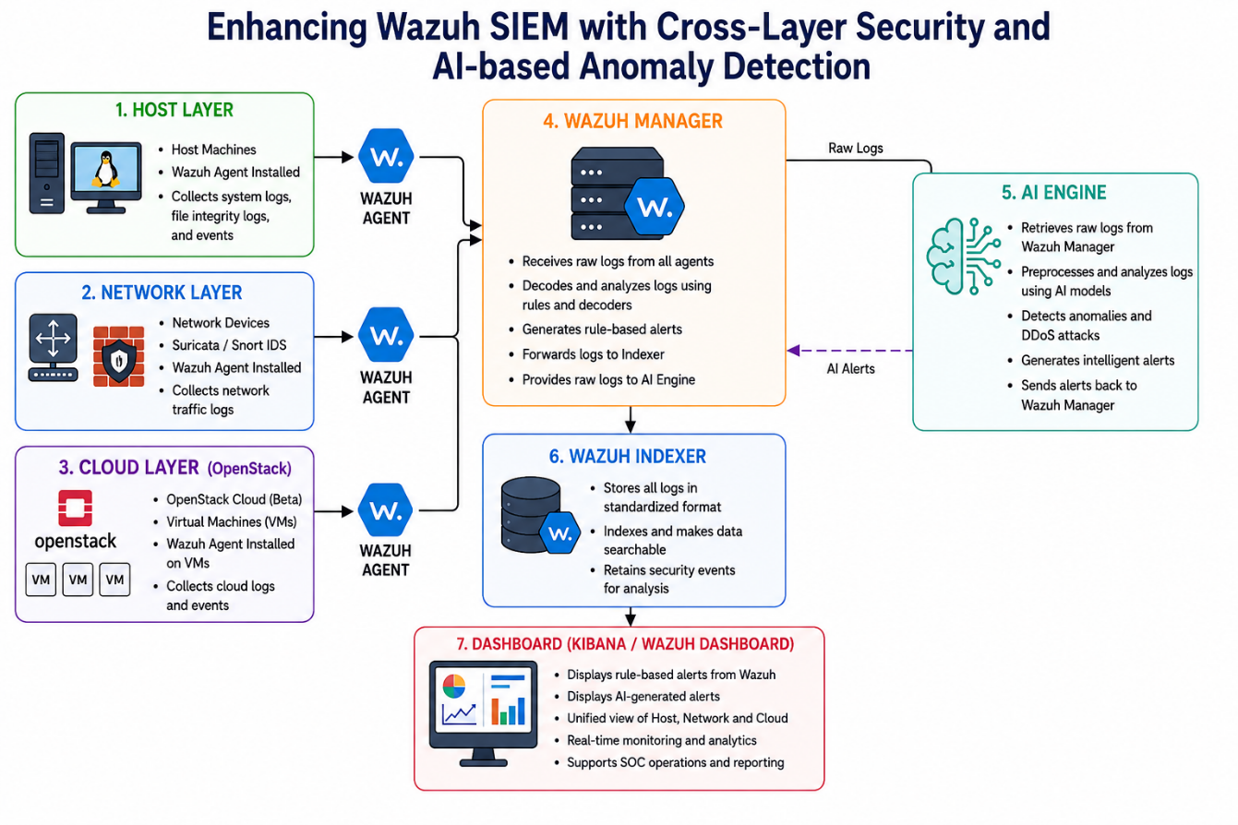
Figure 2: Architecture diagram

Wazuh SIEM Architecture
Wazuh is the central part of the system acting as the SIEM system that collects, analyzes and correlates security events. The Wazuh architecture consists of three main components: Wazuh Manager, Wazuh Agents and the Wazuh dashboard. All the logs are processed, rules defined, and alerts created by the Wazuh Manager if any suspicious operations are detected. Wazuh Agents collect host information on the machines that it's installed, including changes in files, security events and system logs. Finally, the Wazuh console offers a user-friendly interface for alerting, logging and checking the system status.
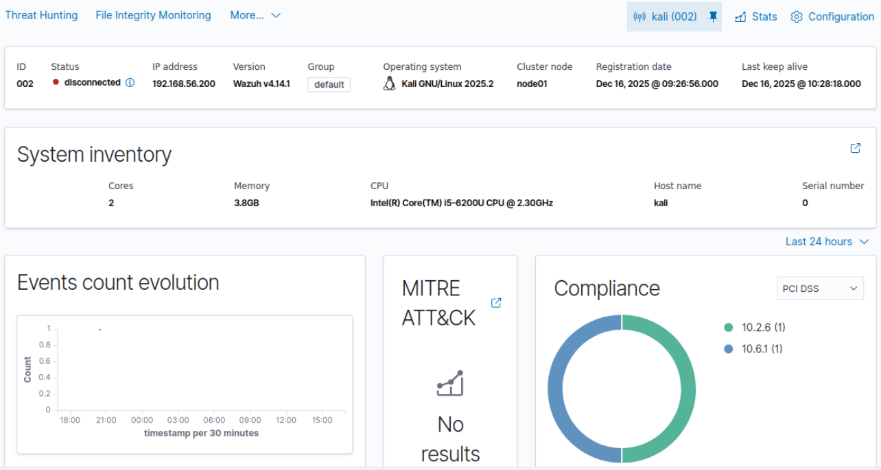
Figure 3: Wazuh visualization

Host-Based Monitoring
Tender Host-Based Monitoring, host-based monitoring uses the Wazuh agent that is installed in endpoints such as Linux and Windows. The Wazuh agents monitor activities performed on the systems including the log files, system calls, file integrity, and user actions. The information gathered by the agents is then sent to the Wazuh Manager, which analyses it to identify any security risks. Such risks include unauthorized access, privilege escalation, and modification of files.
.
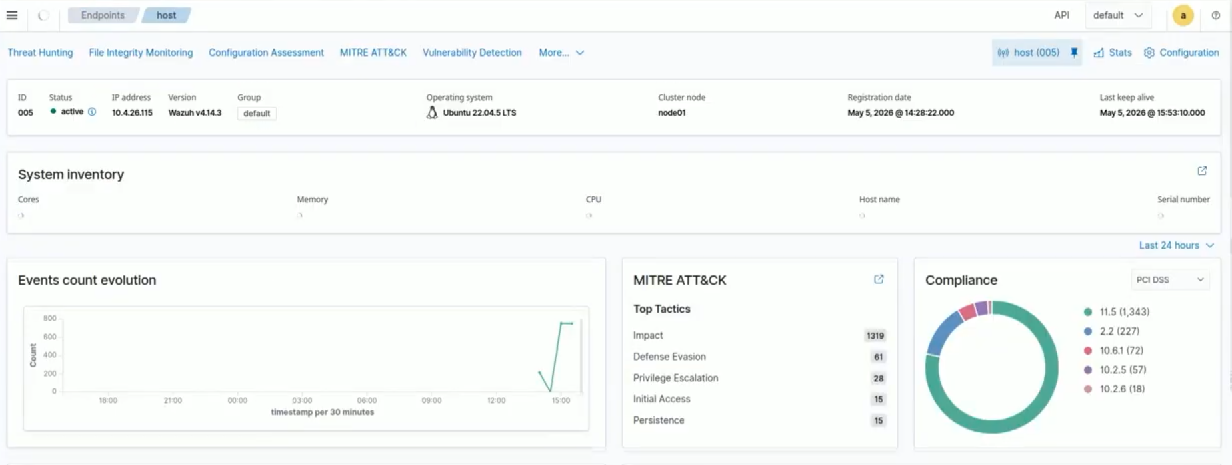

Figure 4: Host connected with Wazuh

The following diagram shows some of the alerts that may occur based on the agent event queue status. These include alerts indicating that the queue is overloaded as well as those showing normal queue load recovery. The dashboard helps security analysts monitor system behavior and detect anomalies as in Figure 5 below.
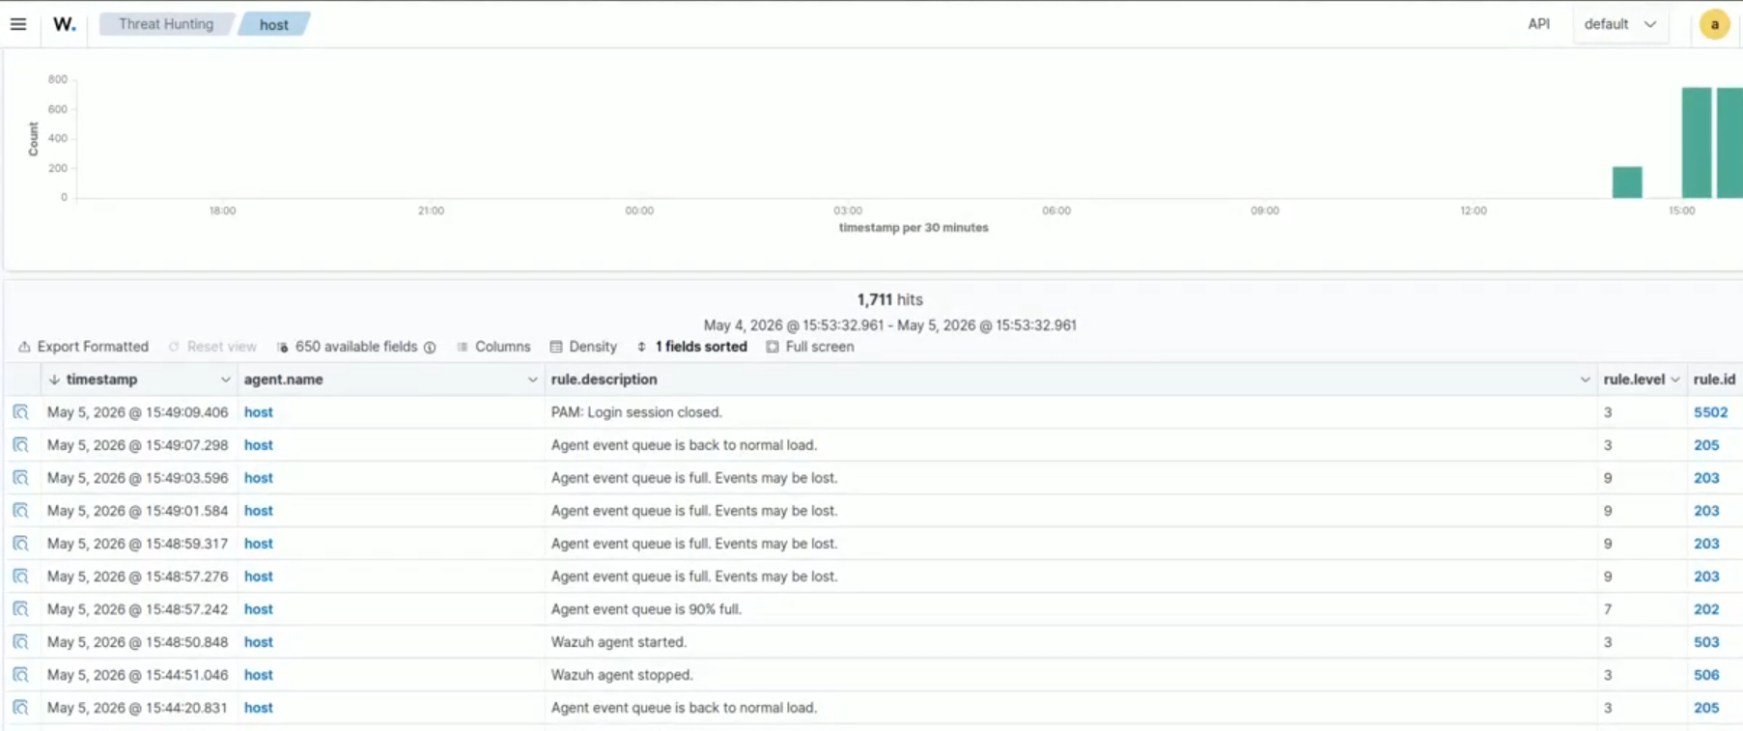
Figure 5: Host logs on wazuh Dashboard
This graph shows the Wazuh security monitoring dashboard where one can see information on total alerts, authentication failures, and the classification of alerts. This allows for easy identification of any suspicious behavior and security trends, as illustrated in Figure 6 below.
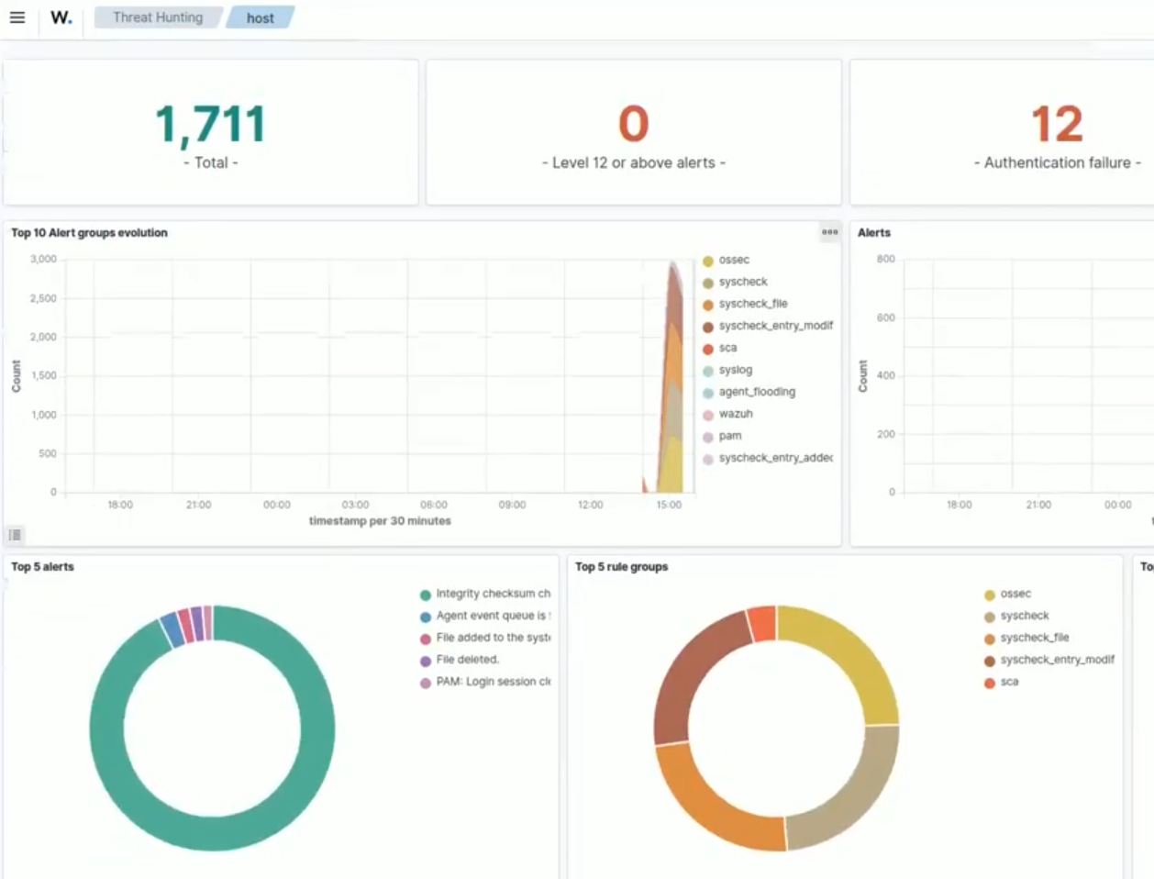
Figure 6: host logs on Threat hunting

Network Monitoring
Monitoring the network is carried out using Suricata, which is an open-source IDS (Intrusion Detection System) used for inspecting and analyzing network traffic in real time. The software captures the network packets and analyzes them based on certain rules and signatures, thereby determining whether there is any malicious activity within the network.
It can detect several kinds of network attacks including port scanning, brute-force attacks, Distributed Denial of Service (DDoS), among others. It creates logs in various structured formats containing details about the sources and destinations of IP addresses, the protocols used, and any threats found.
The logs created by the Suricata system are sent to the Wazuh SIEM system where they are analyzed to detect suspicious activities.

Cloud Monitoring
Cloud monitoring Cloud monitoring was done through deployment of the OpenStack beta version, which was used to provide security visibility and monitoring capabilities in a cloud environment. In this case, a virtual machine was used to create a cloud environment for the purposes of testing and monitoring. The virtual machine acted as a cloud host where activities such as authentication, system actions and user behavior could be monitored in real time.
To achieve centralized security monitoring, Wazuh agent was deployed in the cloud VM. The Wazuh agent was responsible for collecting system logs, authentication logs and security events that occurred within the virtual machine. These events were then transmitted to the central Wazuh manager where they were correlated and processed alongside events received from host and network environments. By doing this, the proposed system would be able to achieve cloud-layer monitoring.
The virtual machine was also remotely accessed from other machines to emulate cloud access in real-world scenario. It was possible for the monitoring system to monitor and detect login attempts and any suspicious behavior in the cloud layer. All cloud layer events were displayed through the Wazuh Dashboard. This made it possible for the system to visualize and generate alerts based on the information.

Backend Processing and Log Management
The backend processing layer is responsible for the management of large amounts of security data collected from various sources, such as host systems, network monitors, firewall logs, and even cloud services. The backend processing layer ensures that the data collected is efficiently processed and structured for subsequent analysis.
The log management layer collects all the security logs in one central place, thus eliminating the need for various distinct systems. Such an approach facilitates the monitoring of system activities, investigation, and threat detection by security analysts. In addition, log management helps avoid redundancy and improves the efficiency of the system as a whole.

Database (Elasticsearch / Log Storage)
Elasticsearch was used as the main database for storing and indexing all security logs and monitoring events. The main advantage of Elasticsearch was the possibility to provide high-performing data storage and searching. It is important to mention that Elasticsearch can be used for storing and processing vast amounts of security-related information obtained from the host systems, network devices, firewalls, and cloud computing environments.
All logs collected by the Wazuh agents, Suricata IDS, UFW Firewall, and cloud monitoring systems were sent to the Elasticsearch after pre-processing and normalization. Logs were stored and structured in Elasticsearch providing the capability to perform effective searches and retrieve security events quickly. Centralized storage allowed improving the management of security information received from different layers.
Real-time visualization and monitoring were performed using the Wazuh Dashboard where quick access to historical and live security events was available. In addition, the possibility to perform searches in logs and investigate suspicious events was provided. Elasticsearch helped to improve the efficiency of the proposed multi-layered security monitoring and AI-based anomaly detection system.

Dashboard Visualization (Kibana)
The users are informed that Kibana will be used as the visualization component of the system, enabling interactive dashboards for monitoring the security events and performance of the system. The information is presented in the form of charts, graphs, and tables, making it easy to conduct analysis.
The dashboard allows the real-time monitoring of the alerts that are created by Wazuh, thus enabling quick detection and reaction to the security threats.

Workflow
The system has a systematic workflow process that makes sure that there is efficient and effective collection, processing, and analysis of the security information. Logs are created from several sources and then analyzed using the SIEM system to look for any possible threats.

Log Collection Process
Logs are gathered through a variety of methods, including those from hosts (Wazuh agents), network (Suricata), firewall (UFW), and cloud infrastructure. These logs are then forwarded to the Wazuh manager for centralization and analysis.
Key components involved:
    - Wazuh Agent: Collects host-based logs (system logs, file integrity, authentication logs)
    - Suricata IDS: Captures and analyzes network traffic
    - UFW Firewall: Generates logs for allowed/blocked traffic
    - Cloud (OpenStack): Provides virtual machine and cloud activity logs
Process flow:
    - Log generation at source
    - Secure forwarding to Wazuh manager
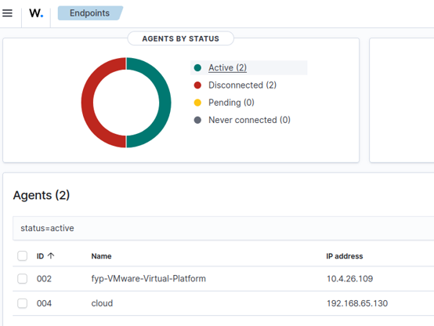
    - Centralized storage for analysis
Figure 7: connected machines using wazuh agent

Log Processing and Normalization
Scraping backend, the logs gathered are then analyzed and transformed into a standardized format to maintain consistency. Wazuh helps in normalization and organization of information which is made possible by easy analysis and event correlation.
Key steps:
- Parsing raw log data
- Converting logs into structured format (JSON)
- Removing redundant or irrelevant data
- Standardizing timestamps and fields
Benefits:
- Improved data consistency
- Faster searching and filtering
- Better correlation across sources
Table 2.

Table 2: Tech stack for Log Processing and Normalization
Component | Technologies / Tools
SIEM Platform | Wazuh
Programming Language | Python
Log Sources | System Logs, Network Logs, Cloud Logs
Data Processing | JSON Parsing, Event Correlation, Log Normalization
Security Tools | Suricata / Snort
Data Storage | Elasticsearch / OpenSearch
Visualization | Kibana / Wazuh Dashboard
AI/ML Processing | Python ML Libraries (Scikit-learn, Pandas, NumPy)
Output Format | Structured Security Alerts / JSON Reports
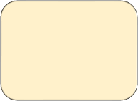
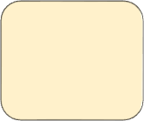

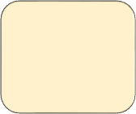


Figure 8: Workflow Diagram

Log Collection
Log processing & normalization
Threat Detection & correlation
AI-based Anomaly detection
Alert Generation & notification
Dashboard
&
Visualization

Alert Generation and Correlation
The system analyzes the processed logs with the help of certain rules and correlation. When there is any suspicious activity, alerts will be produced. The correlation technique can help link together similar activities.
Alert generation is based on:
- Rule-based detection (Wazuh rules)
- Signature matching (Suricata rules)
- Threshold-based triggers (e.g., multiple failed logins)
Correlation process:
- Linking events from different sources
- Identifying attack patterns (e.g., scan → login attempt → intrusion)
- Reducing false positives
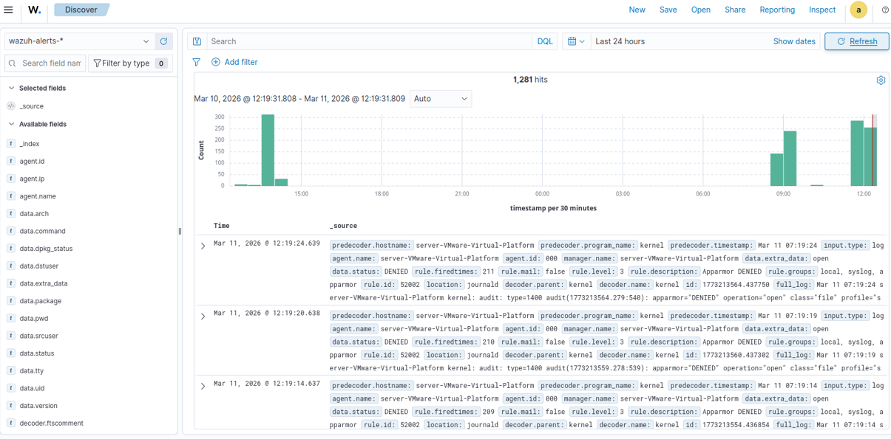
Figure 9: Alert visualization on wazuh

Anomaly Detection Workflow
The machine learning algorithms that are used include the Isolation Forest algorithm and the Random Forest algorithm. Such algorithms will be used to find any abnormal pattern in the data.
Workflow steps:
- Data collection from logs
- Feature extraction (IP, ports, frequency, behavior)
- Model training and testing
- Detection of abnormal behavior
Advantages:
- Detects unknown attacks
- Reduces dependency on predefined rules
- Improves detection accuracy

Notifications & Alerts
Once a threat is detected, the system generates alerts and notifications for security analysts. These alerts are displayed on the dashboard, enabling quick response and effective incident handling.
Alert delivery methods:
- Dashboard alerts (Kibana)
- Log-based notifications
- (Optional) Email / external alerting systems
Key features:
- Real-time alert display
- Severity-based classification (low, medium, high)
- Quick access to detailed logs

Chapter 4: System Requirements and Specifications

Overview

This chapter explains the system requirements and specifications for the proposed AI-integrated Wazuh SIEM system. The chapter describes the functional and non-functional requirements necessary for implementing centralized monitoring, anomaly detection, log processing, and real-time threat analysis across host, network, and cloud environments. In addition, the chapter also discusses the hardware and software requirements required for the successful deployment and operation of the system.

Functional Requirements

Functional requirements describe the core operations and features that the proposed system must perform. These requirements define how the system collects logs, detects threats, generates alerts, and provides monitoring functionalities.

Real-Time Monitoring
The system shall continuously monitor host systems, network traffic, and cloud environments in real time using Wazuh agents and integrated monitoring tools.
Features
- Continuous log collection
- Real-time event monitoring
- Live dashboard visualization
- Monitoring of system activities and network traffic

Centralized Log Collection
The system shall collect logs from multiple sources including hosts, network devices, firewalls, and cloud systems into a centralized SIEM platform.
Features
- Host log collection
- Network traffic logging
- Firewall log monitoring
- Cloud activity monitoring

Threat Detection
The system shall detect suspicious activities and cyber threats using rule-based and AI-based detection techniques.
Features
- Rule-based detection using Wazuh rules
- Signature-based detection using Suricata
- AI-based anomaly detection
- Threat classification

AI-Based Anomaly Detection
The system shall use machine learning algorithms to identify abnormal behavior and unknown threats from collected security logs.
Features
- Detection of abnormal activities
- Behavioral analysis
- Detection of unknown attacks
- Reduced false positives

Alert Generation and Notification
The system shall generate alerts whenever suspicious activities or anomalies are detected.
Features
- Real-time alerts
- Severity-based alert classification
- Dashboard notifications
- Security event visualization

Dashboard Visualization
The system shall provide a centralized dashboard for monitoring logs, alerts, and security events.
Features
- Interactive dashboards
- Security graphs and charts
- Threat visualization
- Real-time monitoring interface
4.3 Non-Functional Requirements
Non-functional requirements describe the quality attributes and operational characteristics of the proposed system.
4.3.1 Performance
The system shall process and analyze security logs efficiently with minimum delay.
Requirements
- Fast log processing
- Real-time alert generation
- Efficient dashboard performance
4.3.2 Scalability
The system shall support future expansion and integration with additional devices, servers, and cloud environments.
Requirements
- Support multiple agents
- Handle large log volumes
- Expandable architecture
4.3.3 Reliability
The system shall provide stable and continuous monitoring services without major failures.
Requirements
- Continuous monitoring
- Reliable log storage
- Stable system operation
4.3.4 Security
The system shall ensure secure communication and protection of monitoring data.
Requirements
- Secure log transmission
- Authentication mechanisms
- Access control
- Data protection
4.3.5 Usability
The system shall provide an easy-to-use interface for security analysts and administrators.
Requirements
- User-friendly dashboard
- Easy alert monitoring
- Simple system management
4.3.6 Maintainability
The system shall be easy to update, configure, and maintain.
Requirements
- Easy configuration
- Flexible rule management
- Simple software updates

4.4 Hardware Requirements
The following hardware components are required for deploying the proposed system.
Component | Requirement
Processor | Intel Core i5 or higher
RAM | Minimum 8 GB
Storage | Minimum 100 GB
Network | Stable internet/network connection
Virtualization | VMware / VirtualBox support
4.5 Software Requirements
The following software tools and technologies are used in the proposed system.
Software | Purpose
Ubuntu Linux | Operating System
Wazuh SIEM | Centralized monitoring
Suricata IDS | Network intrusion detection
Elasticsearch | Log storage and indexing
Kibana | Dashboard visualization
Python | Backend processing and AI integration
Scikit-learn | Machine learning models
OpenStack | Cloud environment
4.6 System Constraints
The proposed system has certain limitations and constraints that may affect system performance.
Constraints
- Dependence on dataset quality
- High storage usage due to large log volumes
- Possible false positives
- Resource consumption during real-time monitoring
- Dependence on network connectivity
4.7 Summary
This chapter presented the functional and non-functional requirements of the proposed AI-based Wazuh SIEM system. It also described the hardware and software requirements necessary for deployment and implementation. These requirements provide the foundation for the successful development and operation of the proposed cybersecurity monitoring system.

Chapter 5: Implementation

Functional Features
The following is an explanation of the essential functional features incorporated into the system for effective monitoring, detection, and handling of cybersecurity threats.

Real-Time Monitoring Feature
The system incorporates a real-time monitoring feature for security events on host, network, and cloud systems. The system monitors security events in real time through continuous collection and analysis of logs.
Key functionalities:
- Continuous log collection from various sources
- Real-time monitoring through Wazuh dashboard
- Real-time data updates and data visualization
- Monitoring of user activities, processes, and network traffic
System capabilities:
- Detect system changes instantly
- Track login attempts and file modifications
- Monitor traffic patterns in real time

Table 3: Real-Time Monitoring Components
Component | Function
Wazuh Agent | Collects host logs in real time
Suricata IDS | Monitors live network traffic
UFW Firewall | Logs real-time access control events
Kibana Dashboard | Displays live monitoring data

The Real-Time Monitoring feature allows for the continuous monitoring of the security incidents that are created by the hosts, networks, and clouds. Logs are collected and analyzed automatically by the system through Wazuh and Suricata to offer immediate insights into suspicious behaviors of the systems. The security analyst is able to monitor alerts, failed authentications, integrity file changes, and network traffic through the central console. If any unusual behavior is detected, the system triggers an alert which is shown immediately.

Table 4: Real-Time Monitoring Requirement
Identifier | FR2
Title | Real-Time Monitoring
Requirement | The system continuously monitors logs, network traffic, and security events in real time
Source | Developer
Rationale | To provide immediate detection and visibility of suspicious activities
Business Rule (if required) | NA
Dependencies | Wazuh Agent, Suricata IDS, UFW Firewall
Priority | High
Output | Security alerts and monitoring data displayed on dashboard
Error | Display warning or alert if monitoring service fails or suspicious activity is detected

Threat Detection and Alerting Feature
The system detects potential threats using rule-based and AI-based techniques and generates alerts for suspicious activities.
Detection methods:
- Rule-based detection (Wazuh rules)
- Signature-based detection (Suricata rules)
- Machine learning-based anomaly detection
Alerting features:
- Real-time alert generation
- Severity classification (Low, Medium, High)
- Centralized alert dashboard
Examples of detected threats:
- Brute-force login attempts
- Unauthorized file changes
- Network scanning attacks

System Setup and Configration

Wazuh Server Installation

The Wazuh server was installed to offer central security monitoring, logging and threat detection services. This installation comprised setting up the Wazuh Manager, Wazuh Indexer and Wazuh Dashboard in the Ubuntu Linux operating system.

Requirements
- Ubuntu Server 22.04 LTS
- Minimum 4 GB RAM and 2 CPU cores
- Stable internet connection
- Sudo/root privileges
- Wazuh installation packages and repositories

Installation Steps
- Update the Ubuntu system packages
- Install Wazuh Manager for log collection and analysis
- Install Wazuh Indexer for storing security events and alerts
- Install Wazuh Dashboard for visualization and monitoring
- Configure services and start Wazuh components
- Access the Wazuh Dashboard through a web browser for monitoring and analysis

Components Installed
- Wazuh Manager
- Wazuh Indexer
- Wazuh Dashboard
The successful installation enabled centralized monitoring and real-time analysis of host, network, and cloud security events.

Wazuh Agent configuration
Wazuh agents were installed on monitored host systems to collect logs and security events in real time. These agents continuously monitored system activities such as login attempts, file changes, running processes, and system events, and forwarded the collected logs to the centralized Wazuh Manager for analysis.

Requirements
- Wazuh server installed and running
- Ubuntu/Windows host machine
- Network connectivity between agent and manager
- Authentication key for secure agent registration
- Sudo/root privileges

Configuration Steps
- Install the Wazuh agent on the host system
- Configure the Wazuh Manager IP address in the agent configuration file
- Register the agent with the Wazuh Manager using an authentication key
- Start and enable the Wazuh agent service
- Verify successful connection between the agent and manager through the Wazuh Dashboard

Functions of Wazuh Agent
- Collect system and security logs
- Monitor file integrity and system changes
- Track login attempts and user activities
- Send real-time events to the Wazuh Manager
- Support centralized threat monitoring and detection
The successful configuration of Wazuh agents enabled real-time monitoring and continuous log collection from host systems within the security environment.

Figure 10: command for installation of wazuh agent

Host, Network, and Cloud Integration
The suggested system will combine monitoring based on host, network, and cloud technologies to give a centralized view of security. Logs and security-related events will be gathered and sent to the Wazuh Manager for further analysis and threat identification.

Requirements
        - Wazuh Manager and Dashboard
        - Wazuh agents installed on host systems
        - Suricata IDS for network monitoring
        - UFW Firewall enabled for firewall logging
        - Internet connectivity for cloud log integration
        - Centralized logging configuration

Integration Process
        - Host systems were integrated using Wazuh agents to collect system logs and endpoint activities
        - Network monitoring was performed using Suricata IDS to detect suspicious traffic and intrusion attempts
        - UFW Firewall logs were collected to monitor blocked and allowed connections
        - Cloud-related logs and events were forwarded to the Wazuh platform for centralized monitoring
        - All logs were aggregated and visualized through the Wazuh Dashboard

Monitored Data Sources
        - System and authentication logs
        - File integrity monitoring logs
        - Network traffic and intrusion alerts
        - Firewall access control events
        - Cloud and server activity logs

Benefits of Integration
        - Centralized monitoring across multiple security layers
        - Improved visibility of security events
        - Better correlation of attacks and suspicious activities
        - Real-time detection of threats and anomalies
        - Enhanced incident investigation and response capabilities
The integration of host, network, and cloud monitoring enabled the system to provide a unified and efficient cybersecurity monitoring environment.

Suricata IDS and UFW Firewall Integration
The IDS called Suricata and the Firewall named UFW were implemented into Wazuh to improve monitoring and traffic analysis on the network. Suricata was responsible for monitoring live traffic and detecting any suspicious activity, whereas UFW Firewall was used to generate logs regarding the allowed and blocked connections on the network.

Requirements
        - Suricata IDS installed and configured
        - UFW Firewall enabled on the system
        - Wazuh Manager and Dashboard
        - Network interface configuration
        - Log forwarding and monitoring enabled

Integration Steps
        - Install and configure Suricata IDS for network traffic monitoring
        - Enable Suricata rule sets for intrusion detection
        - Configure UFW Firewall to log network access events
        - Forward Suricata and UFW logs to the Wazuh Manager
        - Configure Wazuh rules to analyze network and firewall events
        - Visualize alerts and traffic logs on the Wazuh Dashboard

Functions Performed
        - Monitor incoming and outgoing network traffic
        - Detect suspicious packets and scanning activities
        - Log blocked and allowed firewall connections
        - Generate alerts for network-based attacks
        - Support centralized network security monitoring

Benefits
        - Improved network visibility and monitoring
        - Detection of malicious network activities
        - Real-time firewall event monitoring
        - Enhanced threat detection and alerting
        - Better analysis of network-related security incidents
The inclusion of Suricata IDS and UFW Firewall increased the effectiveness of the network security layer of the proposed system and increased its ability to detect threats in real time.

Log Collection and Processing
The proposed system collects logs in real time from various security layers, including hosts, network elements, firewalls, and even cloud computing environments. The collected logs are then analyzed and structured for better monitoring, analysis, and correlation of events.

Requirements
        - Wazuh agents installed on monitored systems
        - Suricata IDS and UFW Firewall configured
        - Wazuh Manager and Dashboard
        - Log forwarding enabled
        - Structured log processing support

Log Collection Process
        - Wazuh agents collect host-based system and security logs
        - Suricata IDS captures network traffic and intrusion alerts
        - UFW Firewall generates logs for allowed and blocked connections
        - Cloud and server events are forwarded to the Wazuh platform
        - All logs are centralized in the Wazuh Manager

Log Processing Steps
        - Parsing raw log data
        - Converting logs into structured JSON format
        - Filtering duplicate or irrelevant events
        - Standardizing timestamps and event fields
        - Categorizing logs based on source and severity

Functions Performed
        - Continuous security event monitoring
        - Log normalization and organization
        - Real-time event analysis
        - Support for threat detection and correlation
        - Improved search and filtering capabilities

Benefits
        - Centralized and organized log management
        - Faster detection of suspicious activities
        - Improved event correlation across security layers
        - Enhanced visibility of system and network activities
        - Efficient security analysis and monitoring
The process of log collection and analysis led to improvement in the efficiency and effectiveness of the entire security monitoring system through consistent and structured security data analysis.

Log Aggregation using Wazuh
The Wazuh tool was adopted as the central point for log aggregation and analysis. The logs collected from the various security layers were transmitted to the Wazuh manager, where they were analyzed and correlated for security threat analysis.

Requirements
        - Wazuh Manager installed and configured
        - Wazuh agents connected to the manager
        - Suricata IDS and UFW Firewall integration
        - Log forwarding enabled from all sources
        - Wazuh Dashboard for monitoring and visualization

Aggregation Workflow
        - Wazuh agents send host logs to the Wazuh Manager
        - Suricata IDS forwards network security alerts
        - UFW Firewall logs network access events
        - Cloud and server logs are centralized in the Wazuh platform
        - Wazuh processes and categorizes all collected events
        - Rules and correlation techniques are applied for analysis

Functions Performed
        - Centralized log storage and management
        - Correlation of events from multiple sources
        - Real-time threat detection and alert generation
        - Monitoring of system, network, and cloud activities
        - Visualization of alerts and logs on the dashboard

Benefits
        - Unified security monitoring platform
        - Improved visibility of security events
        - Faster investigation of suspicious activities
        - Better detection of complex attack patterns
        - Efficient incident analysis and response
Wazuh's log aggregation feature increased the effectiveness of security monitoring due to centralization, event correlation, and real-time analysis of security events across the whole environment.
- Top of Form

- Bottom of Form

5.3 Machine Learning and Anomaly Detection

5.3.1 Machine Learning Model
The system incorporates a machine learning model to enhance threat detection and discover abnormal activities that cannot be detected through conventional methods of detection. The machine learning model is used to analyze security logs and system events from host systems, network traffic, and cloud environments.
Machine learning was incorporated into the Wazuh SIEM platform to increase the efficiency of anomaly detection. The machine learning model was trained using processed log data and security events from different parts of the environment.

Requirements
        - Python programming environment
        - Machine learning libraries (Scikit-learn, Pandas, NumPy)
        - Processed security log dataset

Functions of the Machine Learning Model
        - Analyze security logs and event patterns
        - Identify abnormal or suspicious activities
        - Detect anomalies in real time
        - Support intelligent threat detection

Processing Steps
        - Collection of security logs from Wazuh
        - Data preprocessing and normalization
        - Feature extraction from log events
        - Model training using security datasets
        - Detection of abnormal behavior patterns
        - Send data back to Wazuh and display on dahsboard

Benefits
        - Improved detection of unknown threats
        - Enhanced anomaly detection capabilities
        - Reduction in manual monitoring efforts
        - Better identification of suspicious activities
        - Support for intelligent security analysis
The integration of machine learning improved the capability of the proposed system to detect advanced threats and abnormal activities beyond traditional signature-based detection methods.

5.3.2 Isolation Forest & Random Forest Classification Model
The suggested system combines machine learning techniques with the Wazuh SIEM framework to enhance the threat detection and anomaly analysis capabilities in host, network, and cloud domains. For this purpose, two machine learning models have been employed depending on the nature of the security data under consideration. The Random Forest technique has been applied to the network and cloud security data, whereas Isolation Forest was used for host-based anomalies.
Random Forest Model for Network and Cloud Monitoring
Random Forest is a machine learning algorithm that utilizes several decision trees in classifying an event as either normal or malicious. In this system, the Random Forest model will be used to analyze the network traffic logs, Suricata alerts, and cloud activity logs obtained from the Wazuh.
This model will examine various security attributes including:
• Sources and destinations IPs
• Connections attempts and traffic pattern
• Protocol behavior
• Cloud access events
• Suspected network activities
Following the analysis of the logs, the Random Forest model makes a prediction on whether the event is normal or malicious. The results of the analysis will be converted into alerts which are then fed back to the Wazuh system.
Isolation Forest Model for Host-Based Monitoring
Isolation Forest is an unsupervised anomaly detection method used to detect unusual behavior in a system by isolating abnormal behavior from normal activities. In the suggested system, the model will be analyzing the host-based log data gathered by the Wazuh agents.
The model will be tracking:
• User login activity
• Process execution activity
• File integrity changes
• Resource utilization
• Any unauthorized access attempts
The Isolation Forest model detects anomalies through identifying behavior that differs considerably from normal behavior in a system. When any suspicious behavior is detected, the system will raise an alert and send the alert to the Wazuh Manager for real-time analysis.
Machine Learning Processing Pipeline
The ML pipeline of the suggested system is carried out in the following way:
1. Host systems, network appliances, firewalls, and cloud instances produce logs which are gathered using Wazuh agents and Suricata IDS.
2. The gathered logs are processed, cleaned, and normalized in a structured form, for instance, in JSON format.
3. Security features are extracted from the logs for machine learning.
4. The two ML models, namely Random Forest and Isolation Forest, perform analysis of security events and classify them into normal or abnormal categories.
5. Prediction outcomes are produced using machine learning algorithms.
6. The analyzed data is delivered back to the Wazuh SIEM system via the processing pipeline.
7. Wazuh creates alerts and visualizes detected anomalies on the central dashboard.
Benefits of the Proposed Approach
        - Better detection of cyber attacks and anomalies
• Increased monitoring at host, network, and cloud levels
• Detection of both known and unknown cyber attacks
• Less number of false alarms
• Convergence of AI-driven security analytics and visualization
The combination of the two models – Random Forest and Isolation Forest, along with the Wazuh SIEM software, increased the effectiveness of the proposed cybersecurity monitoring system.

Anomaly Detection Process
The anomaly detection process of the suggested system will be used to detect any abnormalities that take
place in the host, network, or cloud environment. In particular, the anomaly detection process will include the use of Wazuh SIEM solution along with machine learning algorithms to increase the effectiveness of detecting cyber threats and anomalies.

Detection Workflow

The anomaly detection process includes a number of steps, which allow analyzing security events and generating alerts.

Security events and logs are collected from host systems, network components, firewalls, and cloud environments with the help of Wazuh agents and Suricata IDS.

Collected logs are transferred to the Wazuh Manager.

Raw log information is prepared for further analysis by cleaning, normalization, and transformation to JSON format.

Security features, such as login attempts, traffic behavior, file activity, and process activities, are extracted from the logs.

The prepared data is transferred to machine learning algorithms for analysis.

Random Forest algorithm analyzes network and cloud security events.

Isolation Forest algorithm analyzes host-based system activities.

Machine learning models classify events as normal or anomalous.

In case any suspicious or abnormal activity is detected, an anomaly alert is generated and delivered to the Wazuh platform.

Wazuh shows alerts, severity levels, and affected systems on its dashboard.

Types of Detected Anomalies

Brute-force login attempts

Unauthorized file modifications

Suspicious process execution

Abnormal network traffic patterns

Network scanning and intrusion attempts

Unusual cloud access activities

Benefits of the Anomaly Detection Process

Real-time detection of suspicious activities

Improved visibility of abnormal behavior

Early identification of cyber threats

Reduced manual monitoring efforts

Enhanced incident investigation and response

The anomaly detection process improved the capability of the proposed system to identify both known and unknown attacks through intelligent analysis of security logs and system activities.

Integration and System Workflow

Dashboard Flow and Monitoring Interface

Visualization and real-time monitoring of security events gathered from hosts, network devices, firewalls, and cloud services were achieved via the dashboard and monitoring interface. The Wazuh Dashboard served as the main interface for showing alerts, system activities, anomalies, and security statistics.

Through the dashboard, security analysts are able to monitor the security posture of the environment using graphical visualizations, summary of alerts, event logs, and severity levels of threats. The dashboard increases visibility of suspicious activities and assists in investigating security incidents.

Dashboard Workflow

Dashboard workflow involves the following steps:

1. Information about security logs and events are gathered by Wazuh agents, Suricata IDS, UFW Firewall, and cloud sources.

2. Collected logs are forwarded to the Wazuh Manager for processing and correlation.

3. Data obtained from the processed logs are analyzed using Wazuh rules and machine learning models.

4. Anomalies and alerts generated by the analysis process are classified according to the severity level such as Low, Medium, and High.

5. Results of analyzed events and alerts are stored in the Wazuh Indexer.

6. Visualization of monitoring information, alerts, traffic analysis, and anomalies is performed using the Wazuh Dashboard.

Features of the Monitoring Interface

Real-time monitoring of security events

Centralized alert management

Visualization of network and host activities

Display of anomaly detection results

Severity-based alert classification

Search and filtering of logs and events

Graphical representation of attack trends and system activities

Benefits of the Dashboard

Improved visibility of security incidents

Faster investigation of suspicious activities

Real-time monitoring and alerting

Centralized management of logs and alerts

Enhanced analysis of host, network, and cloud security events

The dashboard and monitoring interface improved the usability and effectiveness of the proposed system by providing centralized visualization and real-time analysis of security activities across multiple layers.

Log Storage and Processing Pipeline

The suggested system is based on the centralized log storage and processing pipeline used for handling security events that are collected from host systems, network appliances, firewalls, and cloud services. The pipeline provides a secure way of collecting, processing, analyzing, storing, and visualizing logs.

The Wazuh engine serves as the central point of the suggested pipeline where logs from different sources are gathered and analyzed both in terms of rule-based and machine learning-based methods.

Pipeline Workflow

The log storage and processing pipeline includes the following steps:

1. The Wazuh agents gather logs and events from host-based machines.

2. The Suricata Intrusion Detection System detects malicious activity in the network traffic and generates corresponding alerts.

3. The UFW firewall logs information about blocked and allowed network connections.

4. Logs of cloud services and servers are forwarded to the centralized Wazuh platform.

5. The Wazuh Manager gathers all security logs collected by different means.

6. All raw logs are parsed and normalized and converted to the JSON format.

7. Machine learning algorithms analyze collected data and detect anomalies and suspicious behavior.

8. The analysis results and alerts are stored in the Wazuh Indexer.

9. The Wazuh Dashboard visualizes collected data and generated alerts.

Components of the Pipeline

Wazuh Agents

Wazuh Manager

Wazuh Indexer

Wazuh Dashboard

Suricata IDS

UFW Firewall

Machine Learning Models

Functions Performed

Centralized log collection and storage

Log normalization and event processing

Real-time threat analysis

Anomaly detection using machine learning

Alert generation and visualization

Efficient searching and filtering of security logs

Benefits of the Pipeline

Improved scalability and centralized monitoring

Faster processing of security events

Enhanced threat detection and anomaly analysis

Efficient storage and retrieval of logs

Better visibility of security activities across all layers

The log storage and processing pipeline enhanced the performance of the proposed cybersecurity monitoring system through centralizing its analysis, intelligent detection of threats, and visualization of security events.

Integration and System Workflow

The proposed system integrates multiple security components including Wazuh SIEM, Wazuh agents, Suricata IDS, UFW Firewall, and machine learning models to provide centralized security monitoring and intelligent anomaly detection. The integration enables continuous monitoring of host systems, network traffic, and cloud environments within a unified cybersecurity platform.

The system workflow begins with the collection of security logs and events from different layers of the environment. Wazuh agents collect host-based logs such as authentication events, file integrity changes, process activities, and system logs. Suricata IDS monitors live network traffic and detects suspicious packets, scanning attempts, and intrusion activities. UFW Firewall logs network access control events including blocked and allowed connections. Cloud and server logs are also integrated into the centralized monitoring system.

All collected logs are forwarded to the Wazuh Manager, where the events are processed, normalized, and categorized into a structured format. Wazuh applies rule-based analysis to detect suspicious activities and generate security alerts. The processed security data is then passed through the machine learning pipeline for advanced anomaly detection.

The Random Forest model analyzes network and cloud-related events to classify malicious and normal traffic patterns, while the Isolation Forest model analyzes host-based activities to identify abnormal system behavior and anomalies. After analysis, the machine learning results and anomaly scores are sent back to the Wazuh platform for centralized alert management and visualization.

The Wazuh Dashboard displays real-time alerts, system activities, network traffic analysis, and anomaly detection results for security analysts. Alerts are categorized based on severity levels such as Low, Medium, and High to support efficient investigation and incident response.

The Random Forest algorithm evaluates network events as well as cloud events and categorizes them into malicious traffic and normal traffic. The Isolation Forest algorithm is used to evaluate the behavior of the host machine and detects anomalies. Once the analysis process is completed, the findings from the machine learning algorithms are communicated back to the Wazuh console.

Alerts, system activities, network analysis, and anomalies are displayed by the Wazuh dashboard to help security analysts. The alerts generated are classified according to their severity as low, medium, and high alerts.

System Workflow Steps

Collection of logs from host systems, network devices, firewalls, and cloud sources

Forwarding logs to the centralized Wazuh Manager

Log parsing, normalization, and categorization

Rule-based threat detection using Wazuh and Suricata

Machine learning analysis using Random Forest and Isolation Forest models

Generation of anomaly scores and security alerts

Sending analyzed results back to the Wazuh platform

Storage of events and alerts in the Wazuh Indexer

Visualization of monitoring data and alerts on the Wazuh Dashboard

Benefits of System Integration

Centralized monitoring across multiple security layers

Improved visibility of threats and suspicious activities

Real-time alert generation and anomaly detection

Enhanced correlation of security events

Intelligent analysis using machine learning models

Improved incident investigation and response capabilities

The integration and workflow of the proposed system improved the overall effectiveness of

cybersecurity monitoring by combining SIEM-based monitoring with AI-driven anomaly detection techniques.

Future Enhancements
The proposed system offers centralized security monitoring and AI-enabled anomaly detection for host, network, and cloud environments. Despite the success of the system in enhancing threat detection and real-time monitoring, there are still a number of ways that will make the system scalable, intelligent, and automated in the future.
These improvements might involve incorporating advanced threat intelligence platforms, automated incident response systems, and deep learning algorithms for detection purposes. These features can help in detecting advanced cyber attacks and minimize the manual analysis of security threats.
It is also possible to expand the proposed system to operate within a large enterprise environment characterized by distributed and cloud-native security monitoring. Other capabilities such as visualization and reporting could enhance the performance of security operations.

Possible Future Enhancements
- Integration with advanced threat intelligence feeds
- Automated incident response and alert handling
- Use of deep learning models for advanced anomaly detection
- Support for larger cloud and enterprise environments
- Enhanced visualization and reporting dashboards
- Integration with additional IDS/IPS and security tools
- Real-time automated threat mitigation mechanisms
- Scalable distributed log processing architecture
These future enhancements can improve the intelligence, scalability, and automation capabilities of the proposed cybersecurity monitoring system.

Chapter 6: Result Evaluation
This chapter describes the evaluation and analysis of the proposed cybersecurity monitoring system. The system was evaluated under various attack scenarios in order to analyze the capability of the system to provide real-time monitoring, threat detection, anomaly analysis, and centralized alert management. The performance of the Wazuh SIEM system combined with machine learning algorithms was analyzed on the basis of detection accuracy and alerting.

Experimental Setup
The experimental environment was designed to test the effectiveness of the proposed system in detecting and monitoring cyber threats across host, network, and cloud environments. The setup included the Wazuh SIEM platform, Wazuh agents, Suricata IDS, UFW Firewall, and machine learning models integrated within a virtualized environment.

Components Used
- Wazuh Manager
- Wazuh Dashboard and Indexer
- Wazuh Agents
- Suricata IDS
- UFW Firewall
- Random Forest Model
- Isolation Forest Model
- Ubuntu Linux Environment
- Virtual Machines for testing

Experimental Environment
- Host systems were monitored using Wazuh agents
- Network traffic was analyzed using Suricata IDS
- Firewall activities were logged using UFW Firewall
- Machine learning models analyzed security events for anomaly detection
- Alerts and monitoring data were visualized on the Wazuh Dashboard
The experimental setup enabled testing of real-time monitoring, intrusion detection, and AI-based anomaly detection capabilities of the proposed system.

Attack scenario
Different cyberattack scenarios were simulated to evaluate the effectiveness of the proposed system in detecting suspicious activities and generating alerts.

Simulated Attack Scenarios
- Brute-force login attacks
- Unauthorized file modification attempts
- Network scanning attacks
- Suspicious process execution
- Malicious network traffic activities
- Unauthorized access attempts

Detection Process
- Wazuh rules detected suspicious system and authentication activities
- Suricata IDS identified malicious network traffic and scanning behavior
- Random Forest analyzed network and cloud-related threats
- Isolation Forest detected host-based anomalies and abnormal activities
- The system generated alerts and displayed them on the Wazuh Dashboard in real time
The attack simulations demonstrated the capability of the system to identify both known and unknown threats across multiple security layers.
6.3 Performance Evaluation:
The performance of the proposed Wazuh-based Security Information and Event Management (SIEM) framework was evaluated across network, cloud, and host environments. The framework integrates Wazuh SIEM with machine learning models to enhance threat detection, log analysis, and anomaly identification. A 70% training and 30% testing split was used for supervised models, while the unsupervised model was evaluated using anomaly score distribution and stability analysis. The evaluation demonstrates the effectiveness of the proposed framework in detecting cyber threats and suspicious activities across multiple security layers.
6.3.1 Network Layer Model Evaluation
The Network Layer was evaluated using the Random Forest classifier to identify malicious network traffic and cyberattacks. The dataset was divided into 70% training data and 30% testing data to assess the model's learning and generalization capabilities. Performance was measured using accuracy, precision, recall, F1-score, macro average, and micro average metrics. The results demonstrate excellent classification performance and highly effective attack detection across the network layer.

Metric | Training (70%) | Testing (30%)
Accuracy | 97.8% | 97.2%
Precision | 0.98 | 0.97
Recall | 0.98 | 0.97
F1-Score | 0.98 | 0.97
Macro Average | 0.98 | 0.97
Micro Average | 0.978 | 0.972
6.3.2 Cloud Layer Model Evaluation
The Cloud Layer was evaluated using a Random Forest classifier to distinguish normal cloud activity from suspicious behavior. A 70% training and 30% testing split was employed to evaluate model effectiveness. Performance metrics indicate strong classification capability and consistent detection of suspicious cloud events. The close alignment between training and testing results suggests good generalization and minimal overfitting.
Metric | Training (70%) | Testing (30%)
Accuracy | 95.5% | 95.0%
Precision | 0.95 | 0.95
Recall | 0.95 | 0.95
F1-Score | 0.95 | 0.95
Macro Average | 0.95 | 0.95
Micro Average | 0.955 | 0.950
6.3.3 Host Layer Model Evaluation
The Host Layer employs the Isolation Forest algorithm for unsupervised anomaly detection. Since the model does not require labeled training data, traditional classification metrics such as accuracy, precision, recall, and F1-score are not applicable. Instead, performance is evaluated through anomaly score distribution, contamination rate, and stability analysis. The results indicate consistent anomaly detection performance across both training and testing datasets.

Metric | Training (70%) | Testing (30%)
Contamination Rate | 2% | 2%
Anomaly Score (Min) | -0.177 | -0.182
Anomaly Score (Max) | 0.214 | 0.208
Anomaly Score (Mean) | 0.149 | 0.145
Anomaly Score (Std. Dev.) | 0.057 | 0.061
Stability Agreement Score | 99.2% | 98.1%
Train/Test Split Used: 70% Training and 30% Testing.

Chapter 7: Project Follow-Up and Difficulties faced

Progress

Table 5: Project Progress
Task | Description | Status
Data Collection | Collecting security logs from host systems, network traffic (Suricata), firewall (UFW), and cloud environments. | Completed
Log Processing | Cleaning, parsing, and converting raw logs into structured format (JSON) for analysis. | Completed
Wazuh Setup | Installation and configuration of Wazuh Manager and Agents for centralized log monitoring. | Completed
Network Monitoring Setup | Installation and configuration of Suricata IDS for real-time network traffic analysis. | Completed
Firewall Configuration | Setting up UFW firewall rules and enabling logging for monitoring access control events. | Completed
Log Aggregation | Integrating logs from multiple sources into Wazuh for centralized processing and correlation. | Completed
Machine Learning Model Development | Developing anomaly detection models using Isolation Forest and Random Forest. | Completed
Model Training and Testing | Training and validating machine learning models using collected security datasets. | Completed
Dashboard Development | Configuring Kibana dashboard for visualization of logs, alerts, and system activities. | Completed
System Integration | Integrating Wazuh, Suricata, UFW, ML models, and dashboard into a unified system. | Completed

Difficulties faced
Here are the difficulties faced during the development of the cybersecurity monitoring system:
1. Log Collection Challenges:
- Data Source Diversity: Collecting logs from multiple sources such as host systems, network traffic (Suricata), firewall logs (UFW), and cloud environments was challenging due to differences in log formats and structures.
- Integration Complexity: Ensuring smooth integration between different tools (Wazuh, Suricata, UFW, OpenStack) required careful configuration and compatibility adjustments.
2. Data Processing and Management:
- Log Normalization: Converting logs from various sources into a standardized format took time, as each system generates data differently.
- Large Data Volume: Handling large volumes of log data required efficient processing techniques to avoid performance issues and ensure real-time analysis.
3. Machine Learning Challenges:
- Dataset Preparation: Preparing datasets for machine learning models was difficult due to noisy and unstructured log data.
- Model Accuracy: Achieving high accuracy in anomaly detection required multiple iterations of training and tuning of models such as Isolation Forest and Random Forest.
4. System Configuration Issues:
- Wazuh Setup: Configuring Wazuh Manager and agents correctly across multiple systems required troubleshooting and fine-tuning.
- Rule Management: Creating and modifying detection rules to reduce false positives was a complex and time-consuming task.
5. Visualization and Dashboard Challenges:
- Dashboard Customization: Designing meaningful dashboards in Kibana required understanding of data indexing and visualization techniques.
- Real-Time Updates: Ensuring that logs and alerts are updated in real time without delay was challenging during initial setup.

Chapter 8: Conclusion and Future Enhancement
Cybersecurity monitoring platform using the SIEM technology combined with AI has already been successfully developed for increasing security visibility and threat detection. This platform includes several components such as Wazuh SIEM, Suricata Intrusion Detection System (IDS), firewall logging, and machine learning models. The platform supports such features as centralizing log management, data normalization, real-time analytics, and anomaly detection. The implementation of the proposed monitoring solution allows security analysts to effectively monitor system activities, detect and respond to any threats.
Real-time analytics is one of the main features of the proposed solution, which allows continuous monitoring of security-related events and system behavior. The implementation of machine learning models increases the efficiency of threat detection by identifying any unusual patterns that cannot be detected by traditional rule-based systems. Moreover, the use of visualization on a dashboard provides additional insights into logs, alerts, and performance.
- Centralized monitoring of several systems including host, network, and cloud environments from a single platform.
- Improves intelligence and increases the accuracy of threat detection using machine learning models.
- Increases the effectiveness of real-time incident response due to the generation of alerts and visualization on dashboards.

Future Enhancements
        - Integration of advanced threat intelligence platforms
        - Implementation of automated incident response mechanisms
        - Use of deep learning models for advanced threat analysis
        - Support for large-scale enterprise and cloud-native environments
        - Enhanced visualization and reporting capabilities
        - Integration with additional security monitoring tools
The proposed system provides a strong foundation for intelligent and centralized cybersecurity monitoring and can be further enhanced with advanced AI and threat intelligence capabilities in future work.

REFERENCES
[1] F. Alharbi and A. Alosaimi, “AI-Based Anomaly Detection for Enhanced Cybersecurity in IoT Networks,” in Proceedings of CSNet 2025 International Conference on Cyber Security Networks, 2025.
[2] M. Ahmed and R. Khan, “Integrating SIEM with Zero Trust Architecture for Enhanced Threat Detection,” in Proceedings of the International Cybersecurity Conference, 2025.
[3] F. T. Liu, K. M. Ting and Z.-H. Zhou, “Isolation Forest,” in Proceedings of the IEEE International Conference on Data Mining (ICDM), Pisa, Italy, 2008, pp. 413–422.
[4] M. Du, F. Li, G. Zheng and V. Srikumar, “DeepLog: Anomaly Detection and Diagnosis from System Logs through Deep Learning,” in Proceedings of the ACM SIGSAC Conference on Computer and Communications Security (CCS), Dallas, TX, USA, 2017, pp. 1285–1298.
[5] G. Jakobson and M. D. Weissman, “Alarm Correlation,” IEEE Network, vol. 7, no. 6, pp. 52–59, Nov. 1993.
[6] M. Ahmed, A. N. Mahmood and J. Hu, “A Survey of Network Anomaly Detection Techniques,” Journal of Network and Computer Applications, vol. 60, pp. 19–31, Jan. 2016.
[7] S. Kumar and P. Sharma, “SIEM-Based Framework for Multi-Layer Data Collection and Hybrid Detection,” in Proceedings of the International Conference on Information Security and Cyber Forensics, 2025.
[8] R. Patel and M. Singh, “Integrating Rule-Based SIEM with Machine Learning Detection,” in Proceedings of the International Conference on Cyber Intelligence and Security, 2025.
[9] A. Hassan and M. Tariq, “Machine Learning in SIEM: Intelligent Event Correlation and Anomaly Detection,” International Journal of Information Security, vol. 22, no. 3, pp. 145–160, 2025.
[10] S. Rehman and T. Ali, “Enhancing Open-Source SIEM Using Anomaly Detection Techniques,” International Journal of Computer Networks and Communications Security, vol. 15, no. 5, pp. 201–214, 2025.
[11] J. Smith and L. Brown, “AI-Augmented SOC: Survey of LLMs and Security Operations,” Journal of Cybersecurity and Privacy, vol. 5, no. 2, pp. 88–102, 2025.
[12] A. Khraisat, I. Gondal, P. Vamplew and J. Kamruzzaman, “Survey of Intrusion Detection Systems: Techniques, Datasets and Challenges,” Cybersecurity, vol. 2, no. 1, pp. 1–22, 2019.
[13] M. Ahmed, A. N. Mahmood and J. Hu, “Machine Learning-Based Network Anomaly Detection,” Journal of Network and Computer Applications, vol. 60, pp. 19–31, 2016.
[14] Y. Zhang, H. Wang and X. Li, “Research on Log Anomaly Detection Based on Sentence-BERT,” Electronics, vol. 12, no. 17, pp. 3580–3592, 2023.
[15] K. Wilson and J. Taylor, “Wazuh Security Event Response with Retrieval-Augmented Generation,” Sensors, vol. 25, no. 3, pp. 870–884, 2025.
[16] A. Kumar and S. Lee, “Elasticsearch-Based Threat Hunting for Privilege Escalation Detection,” Future Internet, vol. 17, no. 9, pp. 394–406, 2025.
[17] M. Arif and S. Khan, “AI-Based Embedded Framework for Cyber-Attack Detection,” Applied Sciences, vol. 16, no. 3, pp. 1416–1430, 2025.
[18] H. Patel and R. Verma, “Comprehensive Review of DDoS Detection and Mitigation,” Electronics, vol. 14, no. 21, pp. 4222–4240, 2025.
[19] D. Sharma and P. Gupta, “Distributed Denial of Service Attack Detection in SDN,” Future Internet, vol. 17, no. 4, pp. 136–149, 2025.
[20] T. Johnson and K. Miller, “One-Class Anomaly Detection for Industrial Applications,” Computers, vol. 14, no. 7, pp. 281–294, 2025.
[21] S. Wang and Y. Chen, “Cloud Security Automation Through Threat Detection and Response,” Symmetry, vol. 17, no. 6, pp. 859–872, 2025.
[22] L. Brown and A. Garcia, “Federated Learning for Cloud and Edge Security,” Electronics, vol. 14, no. 5, pp. 1019–1034, 2025.
[23] R. Ahmed and M. Hassan, “Artificial Intelligence as the Next Frontier in Cyber Defense,” Electronics, vol. 14, no. 24, pp. 4853–4868, 2025.
[24] J. Kim and H. Lee, “Machine Learning-Based Intrusion Detection in IoT Systems,” Electronics, vol. 13, no. 18, pp. 3601–3617, 2024.

[25] P. Singh and A. Roy, “Deep Learning vs Machine Learning for Intrusion Detection,” Applied Sciences, vol. 15, no. 4, pp. 1903–1919, 2025.
[26] S. Mehta and R. Das, “AI-Powered Anomaly Detection with Blockchain,” arXiv preprint arXiv:2505.06632, 2025.
[27] Y. Zhao and K. Lin, “Enhanced Anomaly Detection Using Ensemble AI Models,” arXiv preprint arXiv:2502.11854, 2025.

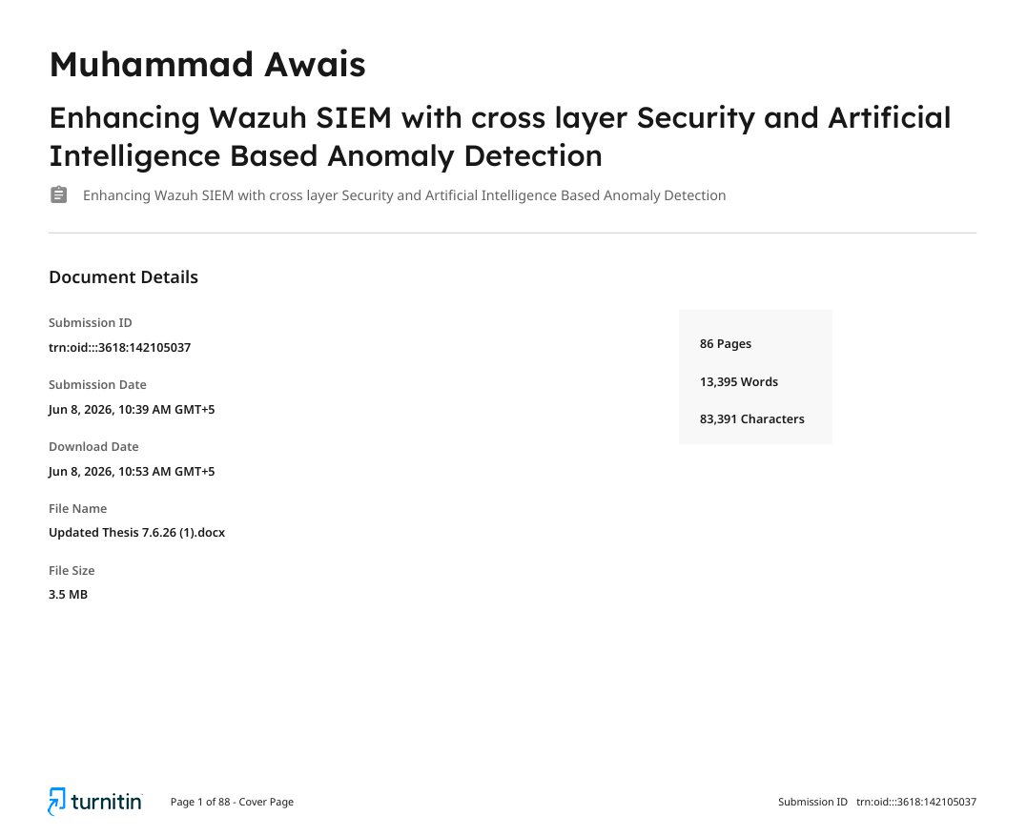
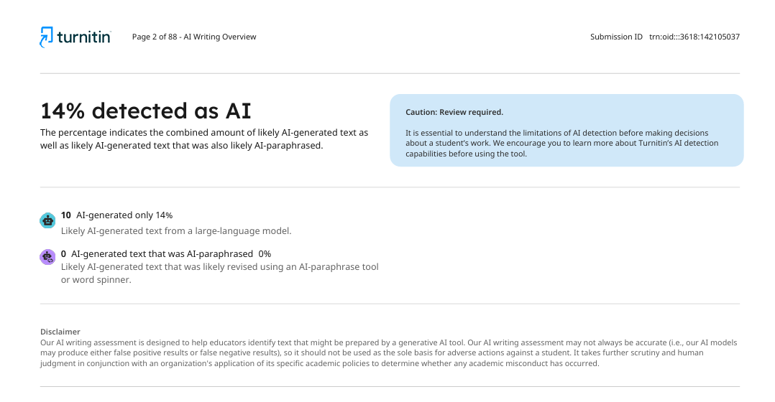
Similarity Report
